**Installing DHT 22 Temperature Sensor**

**A. Installing Adafruit DHT library**

1. Open Terminal
2. Type sudo pip install paho-mqtt
3. Type git clone https://github.com/adafruit/Adafruit_Python_DHT.git
4. Type cd Adafruit_Python_DHT
5. Type sudo apt-get update
6. Type sudo apt-get install build-essential python-dev python-openssl
7. Type sudo python setup.py install
8. Type sudo python3 setup.py install
9. Reboot the Raspberry Pi

Diagram

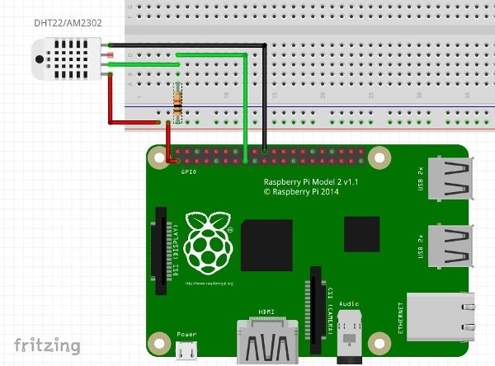

**B. Installing cayenne services**

1.1 Open terminal and type

pip install cayenne-mqtt

It can also be installed from the repository:

1.2. Open terminal and type

git clone https://github.com/myDevicesIoT/Cayenne-MQTT-Python

cd Cayenne-MQTT-Python

python setup.py install

1.3 Reboot

2. Create your Cayenne account at <https://mydevices.com>. Follow the instructions to connect to the raspberry pi.

3. Navigate to **Create App**

3. Add a new device using the Bring Your Own Thing API selection.

4. Click the **Add New..** Button at the upper right. And Select **Device/Widget**

5. Use the usename, password and client id in the python code

**PYTHON SOURCE CODES**

**DHT22.py**

import Adafruit_DHT as dht

h,t = dht.read_retry(dht.DHT22, 4)

print ('Temp={0:0.1f}*C Humidity={1:0.1f}%'.format(t, h))

**CayenneDHT22.py**

import paho.mqtt.client as mqtt

import time

import sys

import Adafruit_DHT

time.sleep(30) #Sleep to allow wireless to connect before starting MQTT

username = "MQTT Username From Dashboard"

password = "MQTT Passsword From Dashboard"

clientid = "MQTT Client ID From Dashboard"

mqttc = mqtt.Client(client_id=clientid)

mqttc.username_pw_set(username, password=password)

mqttc.connect("mqtt.mydevices.com", port=1883, keepalive=60)

mqttc.loop_start()

topic_dht11_temp = "v1/" + username + "/things/" + clientid + "/data/1"

topic_dht11_humidity = "v1/" + username + "/things/" + clientid + "/data/2"

topic_dht22_temp = "v1/" + username + "/things/" + clientid + "/data/3"

topic_dht22_humidity = "v1/" + username + "/things/" + clientid + "/data/4"

while True:

try:

humidity11, temp11 = Adafruit_DHT.read_retry(11, 17) #11 is the sensor type, 17 is the GPIO pin number (not physical pin number)

humidity22, temp22 = Adafruit_DHT.read_retry(22, 18) #22 is the sensor type, 18 is the GPIO pin number (not physical pin number)

if temp11 is not None:

temp11 = "temp,c=" + str(temp11)

mqttc.publish(topic_dht11_temp, payload=temp11, retain=True)

if humidity11 is not None:

humidity11 = "rel_hum,p=" + str(humidity11)

mqttc.publish(topic_dht11_humidity, payload=humidity11, retain=True)

if temp22 is not None:

temp22 = "temp,c=" + str(temp22)

mqttc.publish(topic_dht22_temp, payload=temp22, retain=True)

if humidity22 is not None:

humidity22 = "rel_hum,p=" + str(humidity22)

mqttc.publish(topic_dht22_humidity, payload=humidity22, retain=True)

time.sleep(5)

except (EOFError, SystemExit, KeyboardInterrupt):

mqttc.disconnect()

sys.exit()

References:

<http://community.mydevices.com/t/dht11-dht22-with-raspberry-pi/2015>

<https://www.rototron.info/dht22-tutorial-for-raspberry-pi/>

<https://github.com/myDevicesIoT/Cayenne-MQTT-Python#cayenne-mqtt-python-library>

<https://pypi.python.org/pypi/paho-mqtt/1.2.3>